Day : Loops and Iterations (5-8-2025)

1. Write a program to print numbers from 1 to 100.

#include <stdio.h>

void main()

{

int i;

for(i = 1; i <= 100; i++) {

printf("%d\n", i);

}

}

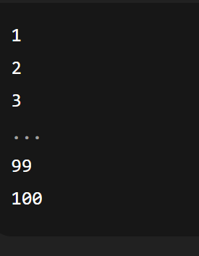

1. Write a program to print even numbers from 1 to 50.

#include <stdio.h>

void main()

{

int i;

for(i = 1; i <= 50; i++)

{

if(i % 2 == 0)

{

printf("%d\n", i);

}

}

}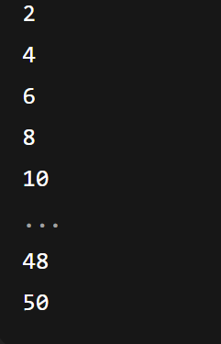

1. Write a program to find the factorial of a number.

#include <stdio.h>

void main

{

int num, i;

unsigned long long factorial = 1;

printf("Enter a positive number: ");

scanf("%d", &num);

if(num < 0) {

printf("Factorial is not defined for negative numbers.\n");

}

Else

{

for(i = 1; i <= num; i++) {

factorial = factorial \* i;

}

printf("Factorial of %d is %llu\n", num, factorial);

}

}

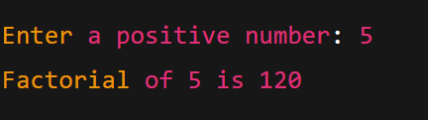

1. Write a program to calculate the sum of digits of a number.

#include <stdio.h>

void main()

{

int num, digit, sum = 0; printf("Enter a number: ");

scanf("%d", &num);

while(num != 0)

{

digit = num % 10; // Get the last digit

sum = sum + digit; // Add digit to sum

num = num / 10; // Remove the last digit

}

printf("Sum of digits = %d\n", sum);

}

1. Write a program to reverse a number.

#include <stdio.h>

Void main()

{

int num, digit, reversed = 0;

printf("Enter a number: ");

scanf("%d", &num);

while(num != 0) {

digit = num % 10;

reversed = reversed \* 10 + digit;

num = num / 10;

}

printf("Reversed number = %d\n", reversed);

}

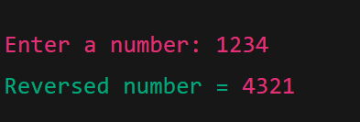

1. Write a program to check whether a number is a palindrome.

#include <stdio.h>

void main()

{

int num, original, reversed = 0, digit;

printf("Enter a number: ");

scanf("%d", &num);

original = num;

while(num != 0) {

digit = num % 10;

reversed = reversed \* 10 + digit;

num = num / 10;

}

if(original == reversed) {

printf("%d is a palindrome.\n", original);

} else {

printf("%d is not a palindrome.\n", original);

}

}

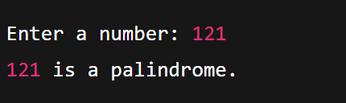

1. Write a program to print multiplication table of a number.

#include <stdio.h>

void main()

{

int num, i;

printf("Enter a number to print its multiplication table: ");

scanf("%d", &num);

for(i = 1; i <= 10; i++) {

printf("%d x %d = %d\n", num, i, num \* i);

}

}

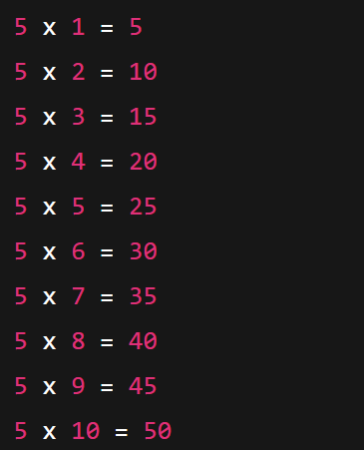

1. Write a program to count the number of digits in a number.

#include <stdio.h>

void main()

{

int num, count = 0;

printf("Enter a number: ");

scanf("%d", &num);

if(num == 0) {

count = 1;

} else

{

if(num < 0)

num = -num;

while(num != 0) {

num = num / 10;

count++;

}

}

printf("Number of digits = %d\n", count);

}

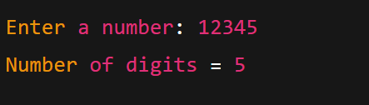

1. Write a program to print the Fibonacci series up to n terms.

#include <stdio.h>

void main()

{

int n, i;

int first = 0, second = 1, next;

printf("Enter the number of terms: ");

scanf("%d", &n);

printf("Fibonacci Series: ");

for(i = 1; i <= n; i++) {

printf("%d ", first);

next = first + second;

first = second;

second = next;

}

}

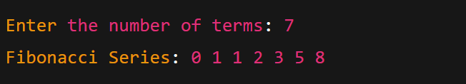

1. Write a program to calculate the sum of the first2

#include <stdio.h>

void main()

{

int a = 1, b = 2;

int sum = a + b;

printf("Sum of %d and %d is %d\n", a, b, sum);

}

